6A^{th} Grade: Unit 13, Lesson 7

- An algebra tile representation is provided. What is the remaining expression after eliminating all the zero pairs?
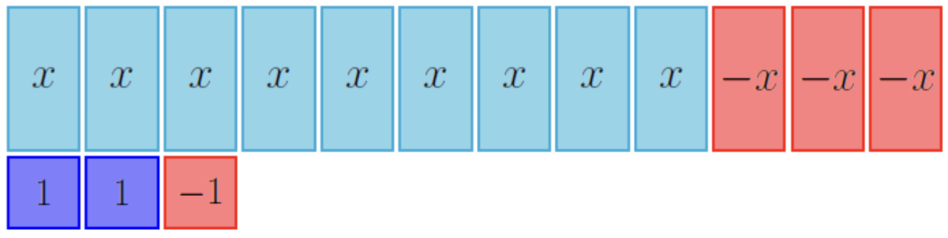

$$6x+1$$

- How many total zero pairs are there in the algebra tiles given?
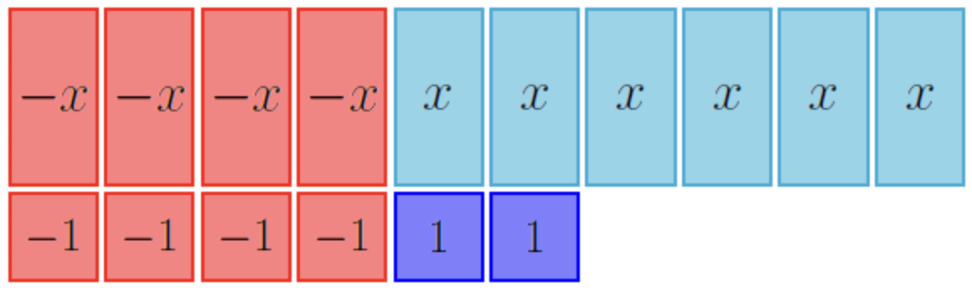

6

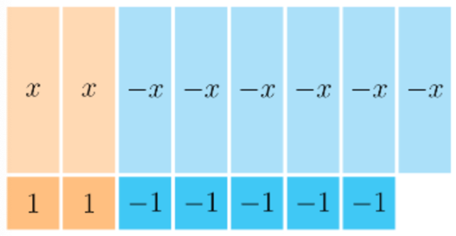
- What is the value of the constant term in the algebraic expression that is being represented by the algebra tiles?

-3

